**Elements, Compounds, and Mixtures: Webquest**

**Section 1: Pure Substances Vs. Mixtures**

Matter can be classified in a few categories. Use this link: <http://www.dummies.com/how-to/content/how-to-distinguish-pure-substances-and-mixtures.html> and complete the chart that is given and define the words in the chart below.

Pure Substance:

* Element:
* Compound:

Mixture:

* Homogenous:
* Heterogeneous:

**Section 2: Elements and Compounds**

Directions: Go to the website below to answer the questions that follow: <http://www.chem.purdue.edu/gchelp/atoms/elements.html>

1. What are the 3 defining characteristics of an element?



2. What is a molecule? (this information is under the ‘element’ information)

3. What are the 4 defining characteristics of a compound?



4. What are the 3 defining characteristics of a mixture?



**Section 3: Homogeneous Mixtures (Solutions) and Heterogeneous Mixtures**

1. Use the following website to fill in the chart below. List examples as well.

<http://www.ducksters.com/science/chemistry/chemical_mixtures.php>

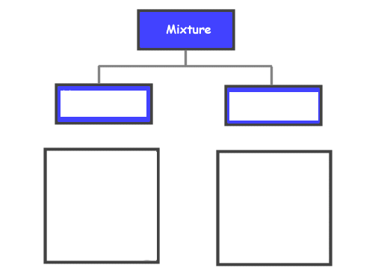

Examples of homogeneous mixtures:

Examples of heterogeneous mixtures:

**Section 4: Quiz!**

Review the information at the top of the following website: <http://www.mrwiggersci.com/chem/tutorials/ch3-rev-pract-classify-matter--blacksburg.htm> Take the quiz and record your answers in the blanks provided.

1. Mercury (Hg):

2. Table salt (NaCl):

3. Pure water:

4. Coffee:

5. Vinegar:

6. Air:

7. Tap water:

8. Gold:

9. Carbon dioxide (CO2):

10. Vegetable soup:

11. Ocean (fish too!):

12. Iron (Fe):

13. Concrete:

14. Wood: